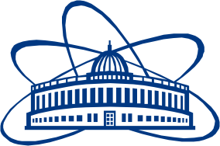

JOINT INSTITUTE FOR NUCLEAR RESEARCH

Dzhelepov Laboratory of Nuclear Problems

**FINAL REPORT ON THE**

**START PROGRAMME**

*Detector and physics simulation using heavy ion collisions at NICA-SPD*

**Supervisor:**

Dr. Igor Igorevich Denisenko

**Student:**

Rishav Pandey, India  
Graduate Engineer Trainee, Larsen & Toubro Limited

**Participation period:**

August 14 – October 8,

Summer Session 2022

Dubna, 2022